SQL Task
Table – Employee Department

USE emp;
CREATE TABLE Department (
dept_id INT PRIMARY KEY AUTO_INCREMENT,
dept_name VARCHAR (50) NOT NULL
);
CREATE TABLE Employee (
emp_id INT PRIMARY KEY AUTO_INCREMENT,
emp_name VARCHAR (50),
salary DECIMAL (10,2),
dept_id INT,
hire_date DATE,
FOREIGN KEY (dept_id) REFERENCES Department(dept_id)
);
INSERT INTO department (dept_name)
VALUES
('HR'),
('IT'),
('Finance');
SELECT * FROM department;
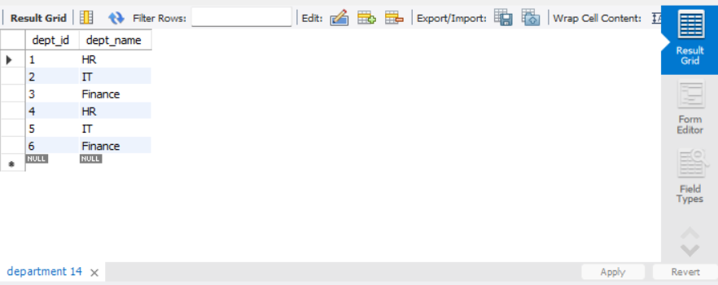
INSERT INTO employee
(emp_name, salary, dept_id, hire_date)
VALUES
('Amit',50000,1,'2025-01-15'),
('Rahul',80000,2,'2025-03-20'),
('Priya',90000,2,'2024-10-10'),
('Sneha',70000,3,'2025-05-01'),
('Karan',60000,1,'2025-02-18'),
('Ankit',95000,2,'2025-04-12'),
('Neha',50000,3,'2025-06-01');
('Neha',50000,3,'2025-07-01'),
('Disha',80000,3,'2025-05-01'),
('Aashu',90000,3,'2025-04-01');
SELECT * FROM employee;
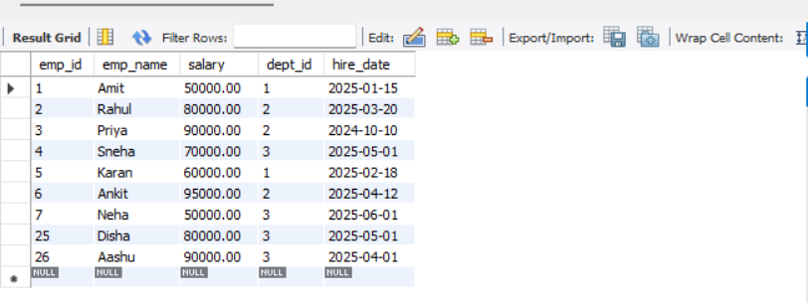
Q1. Top 5 highest salary employees.
SELECT *
FROM Employee
ORDER BY salary DESC
LIMIT 5;

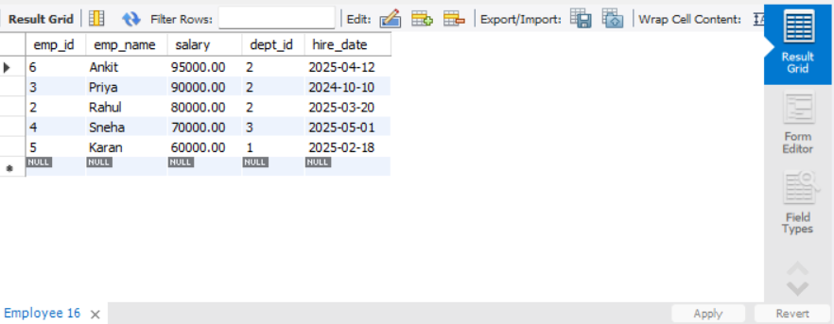
Q2. Department wise employee count.
SELECT d.dept_name,
COUNT (e.emp_id) AS employee_count
FROM Department d
JOIN Employee e
ON d.dept_id = e.dept_id
GROUP BY d.dept_name;
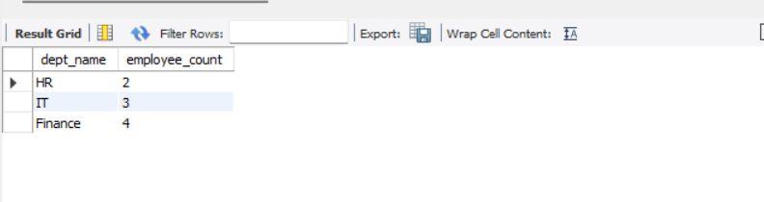
Q3. Find Second highest salary.
SELECT DISTINCT salary
FROM Employee
ORDER BY salary DESC
LIMIT 1 OFFSET 1;
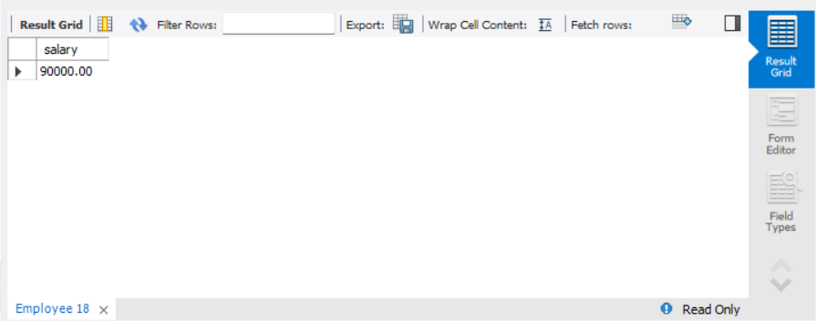
Q4. Employees whose Salary > Department average salary.

SELECT e.*
FROM Employee e
WHERE e.salary >
(
SELECT AVG (salary)
FROM Employee
WHERE dept_id = e.dept_id
);
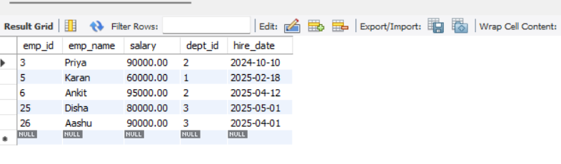
Q5. Inner Join.
SELECT e.emp_id,
e.emp_name,
d.dept_name
FROM employee e
INNER JOIN department d
ON e.dept_id = d.dept_id;
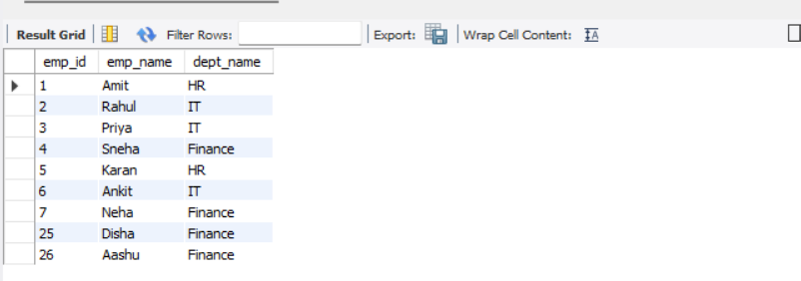
Q6. Left Join.
SELECT d.dept_id,
d.dept_name,
e.emp_name
FROM department d
LEFT JOIN employee e
ON d.dept_id = e.dept_id;
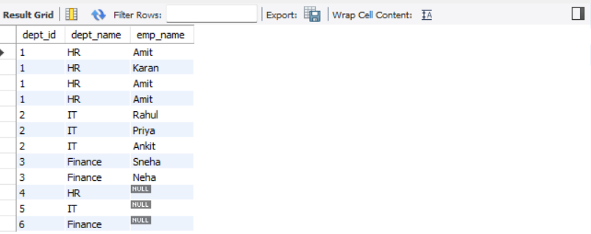
Q7. Group By with Having.
SELECT dept_id,
COUNT (*) AS total_employees
FROM employee
GROUP BY dept_id
HAVING COUNT (*) > 2;
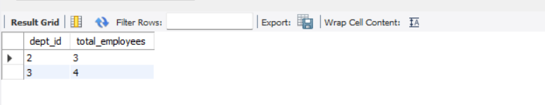
Q8. Employees hired in last 6 months.
SELECT *
FROM employee
WHERE hire_date >= DATE_SUB (CURDATE (), INTERVAL 6 MONTH);
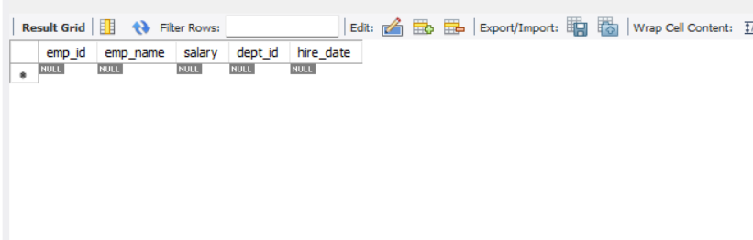
Q9. Find the duplicates records.
SELECT emp_name,
COUNT (*) AS duplicate_count
FROM employee
GROUP BY emp_name
HAVING COUNT (*) > 1;
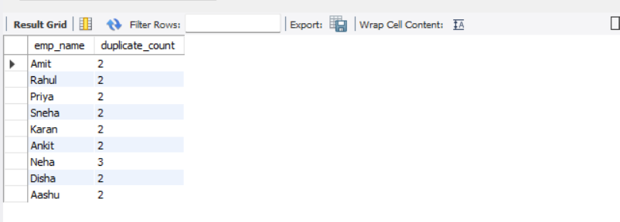
Q10. How to remove duplicate records.
DELETE e1
FROM employee e1
INNER JOIN employee e2
ON e1.emp_name = e2.emp_name
AND e1.emp_id > e2.emp_id;

Q11.Apply window function on the data.
SELECT emp_name,
salary,
RANK () OVER (ORDER BY salary DESC) AS salary_rank
FROM employee;
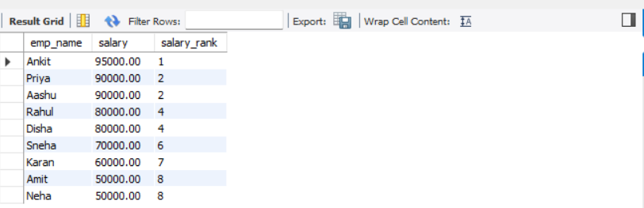
Q12.Apply View on the data.
CREATE VIEW employee_view AS
SELECT emp_name,
salary,
hire_date
FROM employee;

SELECT * FROM employee_view;
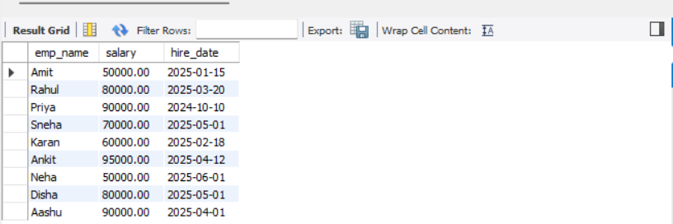
Q13.Apply Triggers on the data.
CREATE TABLE employee_log (
log_id INT AUTO_INCREMENT PRIMARY KEY,
emp_name VARCHAR (50),
action_time TIMESTAMP DEFAULT CURRENT_TIMESTAMP
);

CREATE TRIGGER emp_insert_trigger
AFTER INSERT ON employee
FOR EACH ROW
INSERT INTO employee_log(emp_name)
VALUES (NEW.emp_name);
INSERT INTO employee
(emp_name,salary,dept_id,hire_date)
VALUES
('TestUser',50000,1, CURDATE ());
SELECT * FROM employee_log;
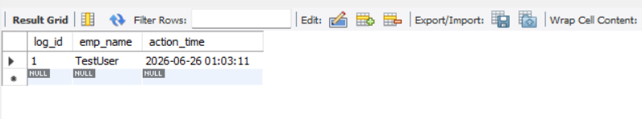
Q14.Handle Case When in the data.
SELECT emp_name,
salary,
CASE
WHEN salary >= 90000 THEN 'High Salary'
WHEN salary >= 70000 THEN 'Medium Salary'
ELSE 'Low Salary'
END AS salary_category
FROM employee;
